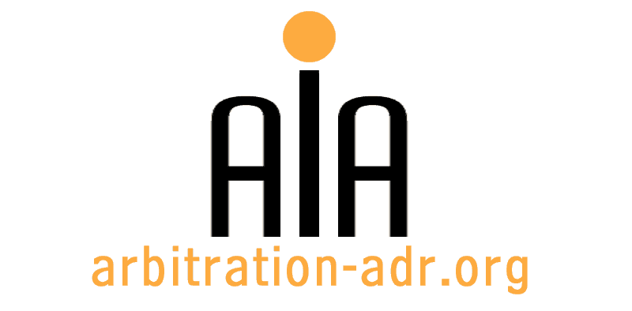

Association for International Arbitration
Avenue Louise 146/9, 1050 Brussels, Belgium

+32 2 643 3301 http://www.arbitration-adr.org
+32 2 646 2431
CONFERENCE REGISTRATION FORM
ADR in the Aviation Sector and the sector of
Tour Operators

organised by the Association for International Arbitration

When? This event will take place on 24 June 2011 from 1.30 pm until 6.30 pm
Registration will start at 1.00 pm

Where? VUB University Brussels, Pleinlaan 2, B-1050 Brussels, Belgium

Last Name |  |  |  |  |  |  |  |  | First name
Profession |  |  |  |  |  |  |  |  | Organisation
Address |  |  |  |  |  |  |  |  |  |  | Phone
 |  |  |  |  | Zip Code
City |  |  | State |  |  |  |  |  |  |  | Fax
Country |  |  |  |  |  |  |  |  |  |  | Email
Do you need a certificate of participation? |  |  |  |  | Yes | No |  |  |  |  | Date
Invoice receivers address
(If different from the address above)
ING Bank Belgium
Marnixlaan 24
1000 Brussels
Belgium AIA
Johan Billiet
IBAN paper form: BE18 3101 6881 6765 IBAN electronic form: BE18310168816765 BIC/SWIFT code: BBRUBEBB
Address
 |  |  |  |  | Zip Code
City |  |  | State
Country
VAT

Payment details: 121 € for non-members (21% VAT included)
84 € for AIA members and students (21 % VAT included)

