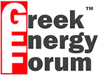
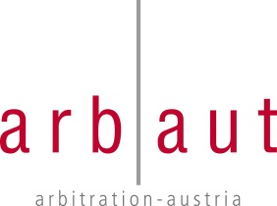
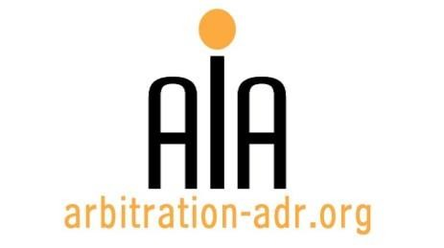

SEMINAR: ENERGY AND ARBITRATION

ORGANIZERS:
- The Association for International Arbitration (AIA);
- The Vienna International Arbitral Centre (VIAC);
- Arbitration Austria (ARBAUT); and
- The Greek Energy Forum (GEF)
SEMINAR NAME: Energy and Arbitration
TARGET GROUPS: Attorneys specializing in dispute resolution, in-house counsels, a.o.

DATE: 19 May 2016

TIME: 14.00-18.30h

LOCATION: VUB University, Pleinlaan 9, 1050 Brussels. (Room WEBER – 1st Floor)

LANGUAGE: English.

FEE: 200 EUR (VAT excluded)
(AIA members, VIAC, Arbaut and GEF members receive a 50 % discount)

(PLACES ARE LIMITED AND ARE ALLOCATED ON A FIRST COME FIRST SERVED BASIS)

PROGRAM
Time allocation
Welcome |  | Introduction & welcome  (Johan Billiet, President of AIA) |  |  | 14.00 – 14.10
First Panel
(Moderator: Dr. Iñigo del Guayo)

2. | “Energy Arbitration, EU Law and Russia.” |  |  | Graham Coop,  Volterra Fietta | 14.10 – 14.30
3. | “Designating Arbitration Clauses in energy contracts: A prerequisite to efficient arbitration proceedings.” |  |  | Orestis Omran  Dentons | 14.30 – 14.50
4. | “How do oil, gas and renewables claims differ in international arbitrations?  Practical analysis through mining arbitration cases.” |  |  | Peter Cameron  Director Centre for  Energy, Petroleum and  Mineral Law | 14.50 – 15.10
5. | “Relations between the new International Energy Charter and the Energy Charter Treaty.” |  |  | Ernesto Bonafe  Regulatory expert at the Energy Charter Secretariat | 15.10 – 15.30
6. | Q&A |  |  |  | 15.30 – 15.50
Coffee break: 15.50 – 16.20

Second panel
(Moderator: Sebastiaan Holslag, Billiet & Co)
7. |  |  | “A Bird’s Eye View of the ECT Investor-Contracting Party Dispute Settlement Mechanism: problems and conjecture.” | Sergej Dilevka, Mena Chambers | 16.20 – 16.40
8. |  |  | “Arbitrating energy disputes: the SCC experience.” | Natalia Petrik, Stockholm Chamber of Commerce | 16.40 – 17.00
9. |  |  | “Compensation for damages in energy disputes.” | Christian W. Konrad, Konrad and Partners | 17.00 – 17.20
10. |  |  | Q & A and debate |  | 17.20 – 17.40
CONCLUDING REMARKS |  |  | Konstantinos Adamantopoulos,  KA LEGAL |  | 17.40 – 17.50
Networking reception: 17.50 – 18.30

REGISTRATION FORM

First Name Last Name

Occupation Organization

VAT number Billing address

Telephone Fax /
Fee:

o Tick this box if you are a professional: 200 € (excl. VAT)

o Tick this box if you are a member of AIA, VIAC, Arbaut or GEF Member (reduced fee: 100 Euro excl. VAT)

Email ________________________________________________________

Signature

(Send this form to Philippe.Billiet@billiet-co.be)

[Feel free to suggest future events or become partner to future events]

[For other AIA events, see: www.arbitration-adr.org/activities/?p=conference&a=upcoming]

[This event is supported by Billiet & Co Lawyers, Arbitrators & Mediators]

