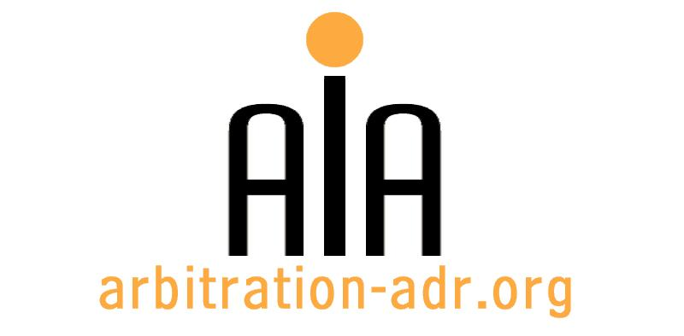

The Association for International Arbitration IVZW

Avenue Louise 146, B-1050 Brussels
tel.: +(32) 2 643 33 01
fax: +(32) 2 646 24 31
e-mail: administration@arbitration-adr.org
web: www.arbitration-adr.org

Energy and Arbitration

ORGANIZER: The Association for International Arbitration (AIA) IVZW.

DESCRIPTION: Event co-organized with the vienna international arbitration centre (viac) and the austrian arbitration association (arbaut)

TARGET GROUPS: Lawyers, in-house counsel, students.

ADDED VALUE: This seminar looks at commercial arbitration in the energy sector, particularly in the oil and gas sector. In particular, speakers will discuss investment arbitration and the Energy Charter Treaty (ECT), focusing on dispute resolution under the ECT, the future of the ECT and the implementation of the ECT in transit disputes.

DATE: May 19, 2016

TIME: 14.00-18.30.

LOCATION:

LANGUAGE: English.

FEE: 200 EUR (VAT excluded).

(PLACES ARE LIMITED AND ARE ALLOCATED ON A FIRST COME FIRST SERVED BASIS)

REGISTRATION FORM

First Name ____________________________ Last Name _________________________________
Occupation ____________________________Organization_______________________________
VAT number___________________________ Billing address______________________________
_________________________________________________________________________________
Telephone __________________________ Fax ________/_________________________________

Fee:

- 60 € (VAT excluded)

Email ____________________________________________________________________________
Signature ________________________________________________________________________

[Feel also free to suggest future events or become partner to future events]

[For other AIA events, see: www.arbitration-adr.org/activities/?p=conference&a=upcoming]

