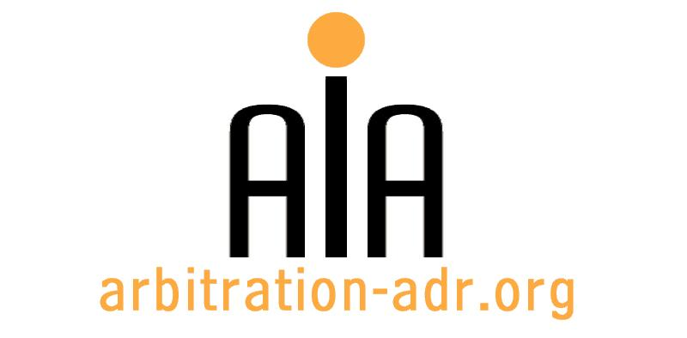

The Association for International Arbitration IVZW

Avenue Louise 146, B-1050 Brussels
tel.: +(32) 2 643 33 01
fax: +(32) 2 646 24 31
e-mail: administration@arbitration-adr.org
web: www.arbitration-adr.org

Third party funding

ORGANIZER: The Association for International Arbitration (AIA) IVZW.

DESCRIPTION: EVENT CO-ORGANIZED WITH THE DANISH INSTITUTE FOR ARBITRATION

TARGET GROUPS: Lawyers, in-house counsel, students.

ADDED VALUE: There has been a constant spotlight on third party funding in international arbitration over the years. In this seminar, we will discuss the mandatory disclosure of funding agreements in investment and commercial arbitration, the needs for rules regulating TPF in arbitration, role of respondents and the impact of TPF on arbitral proceedings.

DATE: June 9, 2016

TIME: 14.00-18.30.

LOCATION:

LANGUAGE: English.

FEE: 200 EUR (VAT excluded).

(PLACES ARE LIMITED AND ARE ALLOCATED ON A FIRST COME FIRST SERVED BASIS)

REGISTRATION FORM

First Name ____________________________ Last Name _________________________________
Occupation ____________________________Organization_______________________________
VAT number___________________________ Billing address______________________________
_________________________________________________________________________________
Telephone __________________________ Fax ________/_________________________________

Fee:

- 60 € (VAT excluded)

Email ____________________________________________________________________________
Signature ________________________________________________________________________

[Feel also free to suggest future events or become partner to future events]

[For other AIA events, see: www.arbitration-adr.org/activities/?p=conference&a=upcoming]

