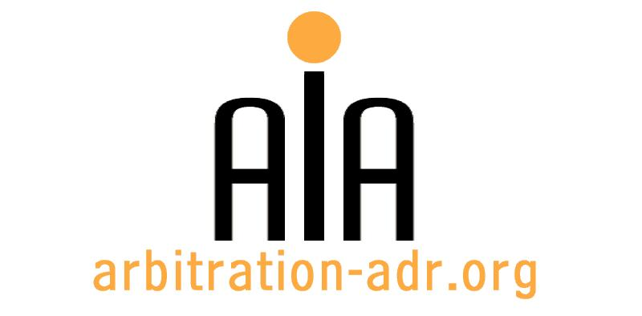

The Association for International Arbitration IVZW

Avenue Louise 146, B-1050 Brussels
tel.: +(32) 2 643 33 01
fax: +(32) 2 646 24 31
e-mail: administration@arbitration-adr.org
web: www.arbitration-adr.org

Master Class on Investment Arbitration

ORGANIZER: The Association for International Arbitration (AIA) IVZW.

DESCRIPTION: The Master Class is organized together Brussels Diplomatic Academy.

TARGET GROUPS: Lawyers, in-house counsel, students.

ADDED VALUE: The law on foreign investment protection is one of the fastest developing and intellectually challenging branches of international law with high practical relevance. Investment arbitration is predicted to be a major factor in the development of the global economic system.

DATE: 26 – 29 September, 2016

TIME:

LOCATION: IEU (VUB)

LANGUAGE: English.

FEE: 1850 EUR (VAT excl.) / AIA Members.: 925 EUR (VAT excl.)

(PLACES ARE LIMITED AND ARE ALLOCATED ON A FIRST COME FIRST SERVED BASIS)

REGISTRATION FORM

First Name ____________________________ Last Name _________________________________
Occupation ____________________________Organization_______________________________
VAT number___________________________ Billing address______________________________
_________________________________________________________________________________
Telephone __________________________ Fax ________/_________________________________

Fee:

- 60 € (VAT excluded)

Email ____________________________________________________________________________
Signature ________________________________________________________________________

[Feel also free to suggest future events or become partner to future events]

[For other AIA events, see: www.arbitration-adr.org/activities/?p=conference&a=upcoming]

