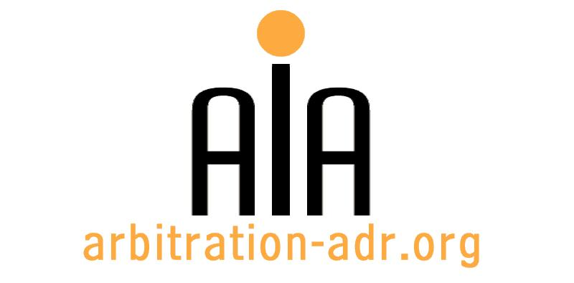

The Association for International Arbitration IVZW

Avenue Louise 146, B-1050 Brussels
tel.: +(32) 2 643 33 01
fax: +(32) 2 646 24 31
e-mail: administration@arbitration-adr.org
web: www.arbitration-adr.org

INTRODUCTION TO MEDIATION

ORGANIZER: The Association for International Arbitration (AIA) IVZW

PROJECT NAME: Introduction to Mediation

DESCRIPTION: This three day training program is designed to provide an introduction to the theory and practice of mediation and focuses on the development of relevant introductory skills. It is suitable for those at all levels who seek to enhance their knowledge and skills in relation to conflict resolution.

LOCATION: AIA Office, Louizalaan 146, 1050 Brussels, Belgium

DATE: 7 – 9 December 2016 (9.30am – 6pm)

LANGUAGE: English

REGISTRATION FORM

First Name ____________________________ Last Name _________________________________
Occupation ____________________________Organization_______________________________
VAT number___________________________ Billing address______________________________
_________________________________________________________________________________
Telephone __________________________ Fax ________/_________________________________

Fee:
- Registration fee: 400 Euros (VAT excluded) – 50% discount for AIA members

Email ____________________________________________________________________________
Signature ________________________________________________________________________

☐ Tick this box if you are an AIA member and benefit from a 50% discount

(Send this form to Philippe.Billiet@billiet-co.be)

[Feel free to suggest future events or become partner to future events]

[For other AIA events, see: www.arbitration-adr.org/activities/?p=conference&a=upcoming]

[This event is supported by Billiet & Co Lawyers, Arbitrators & Mediators]

