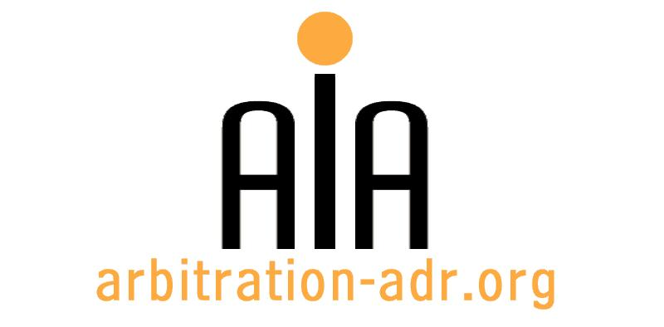

The Association for International Arbitration IVZW

Avenue Louise 146, B-1050 Brussels
tel.: +(32) 2 643 33 01
fax: +(32) 2 646 24 31
e-mail: administration@arbitration-adr.org
web: www.arbitration-adr.org

IMI QUALIFYING ASSESSMENT PROGRAM (approved by the International Mediation Institute)

ORGANIZER: The Association for International Arbitration (AIA) IVZW

PROJECT NAME: Qualifying Assessment Program (QAP)

DESCRIPTION: The AIA is pleased to announce that we now have a Qualifying Assessment Program (QAP) approved by the International Mediation Institute (IMI). Those who take part in the AIA’s qualifying assessment program and successfully become qualified and then IMI Certified will form part of a worldwide community of experienced mediators who’s Profiles are freely searchable by users through the IMI open search engine.

! Condition !: Applicants must demonstrate 200 hours mediation experience and 20 mediation cases.
LOCATION: AIA Office, Louizalaan 146, 1050 Brussels, Belgium

DATE: 28 August 2016

LANGUAGE: English

MORE INFORMATION: https://imimediation.org/about-imi-home

REGISTRATION FORM

First Name ____________________________ Last Name _________________________________
Occupation ____________________________Organization_______________________________
VAT number___________________________ Billing address______________________________
_________________________________________________________________________________
Telephone __________________________ Fax ________/_________________________________

Fee:

- Registration fee: 800 Euros (VAT excluded);
(50% reduction for AIA members)
Email ____________________________________________________________________________
Signature ________________________________________________________________________

☐ Tick this box if you are an AIA member and benefit from a 50% discount

(Send this form with attachments to philippe.billiet@billiet-co.be)

[REGISTRATION IS SUBJECT TO DEMONSTRATING AT LEAST 200 HOURS MEDIATION EXPERIENCE AND 20 MEDIATION CASES]

[Feel free to suggest future events or become partner to future events]

[For other AIA events, see: www.arbitration-adr.org/activities/?p=conference&a=upcoming]

[This event is supported by Billiet & Co Lawyers, Arbitrators & Mediators]

